***DESIGN PROCESS – SOFTWARE DEVELOPMENT***

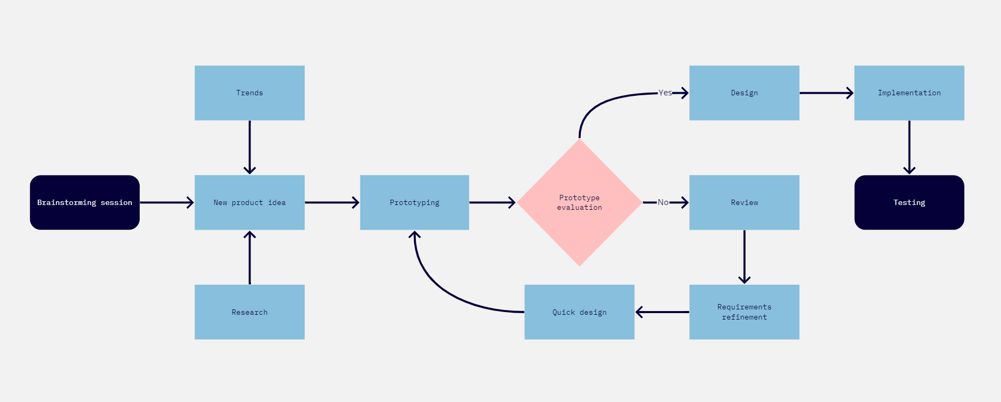

***TESTING & POST INSTALLATION – BUG TRACKING***

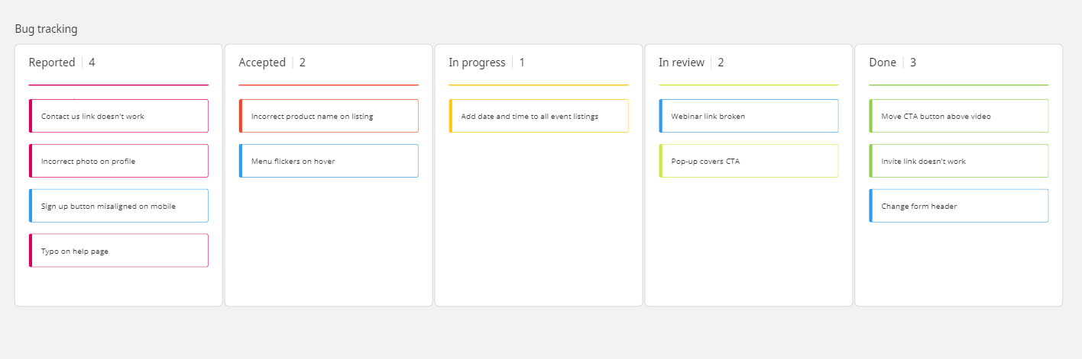

***CLASS – COMPANY STRUCTURE*** 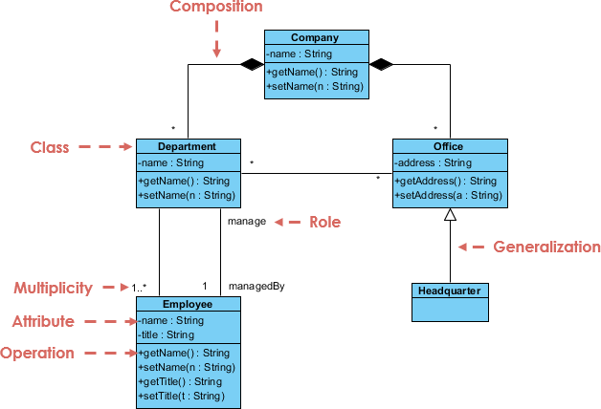

***CLASS – USE OF THE TELEPHONE***

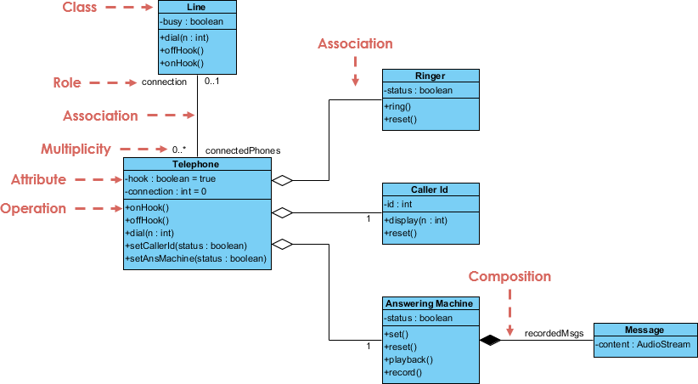

***CLASS – TICKET SALES***

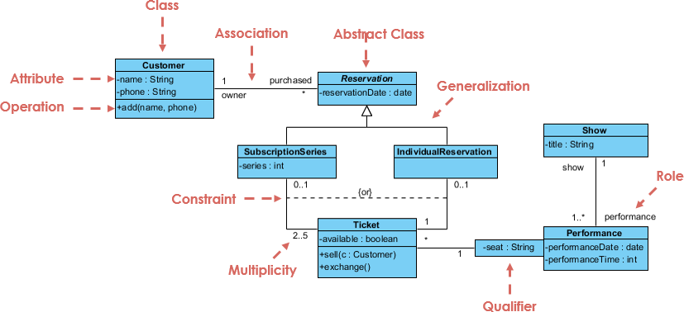

***CLASS – SALES ORDER SYSTEM***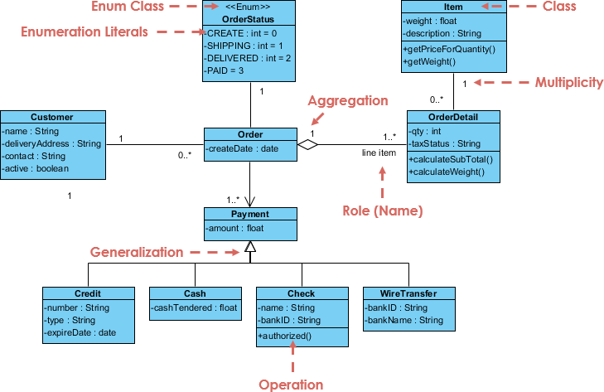

***UML USE CASE – BANK ATM***

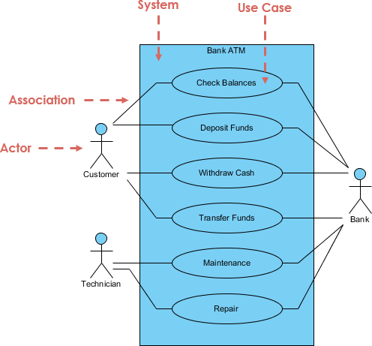

***UML USE CASE – ORDER PROCESS SYSTEM***

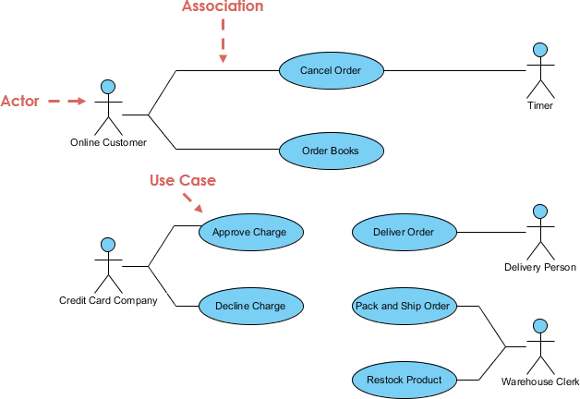

***UML USE CASE – ONLINE LIBRARY SYSTEM***

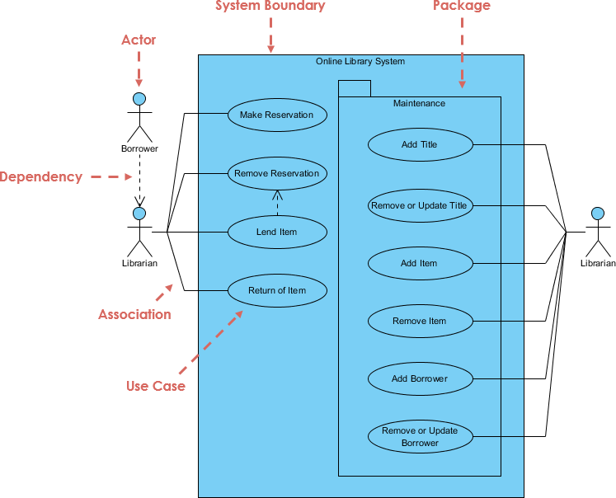

***UML USE CASE – SOFTWARE DEVELOPMENT MANAGEMENT***

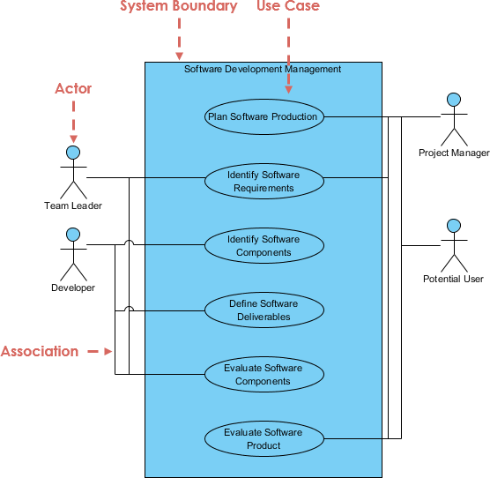

***UML USE CASE – ATM***

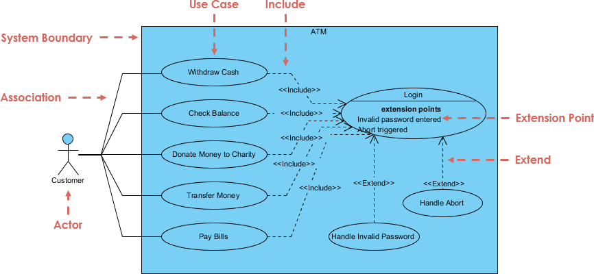

***SEQUENCE DIAGRAM – MAKE A PHONE CALL***

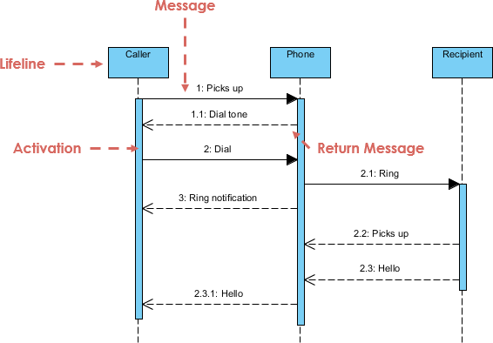

***SEQUENCE DIAGRAM – PLACE AN ORDER***

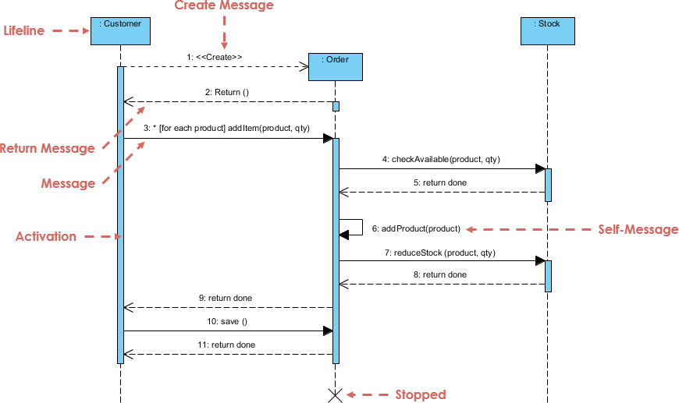

***EPC DIAGRAM – BILLING PROCESS***

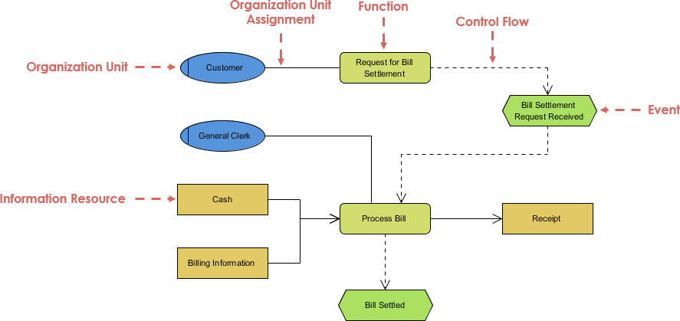

***EPC DIAGRAM – SIMPLE TEMPLATE***

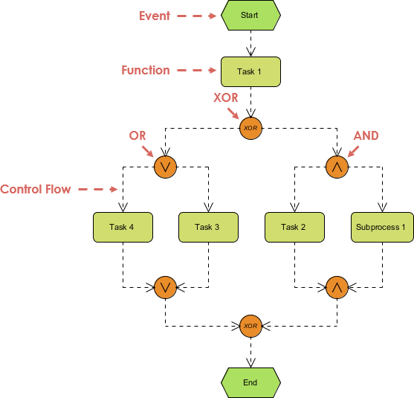

***EPC DIAGRAM – GOODS ARRIVAL***

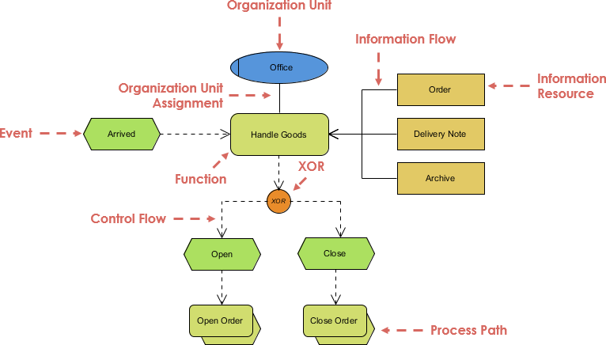

***EPC DIAGRAM – ONLINE ARTICLE PROCESS***

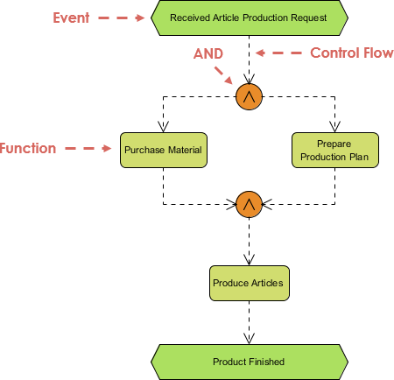

***SWIMLANE DIAGRAM – ORDER FULFILMENT***

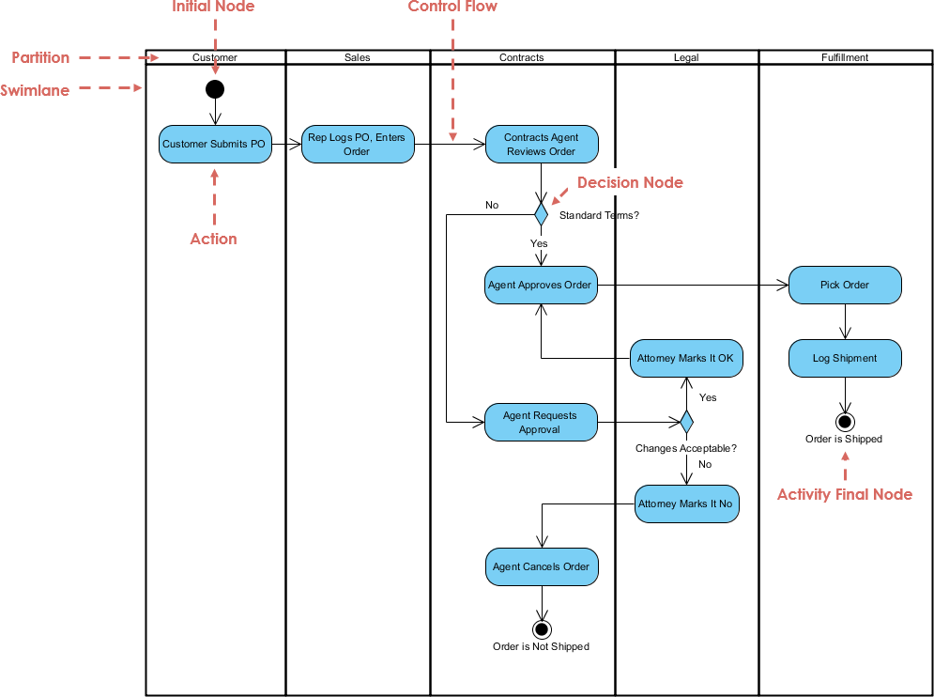

***SWIMLANE DIAGRAM – COMPLETING AN ASSIGNMENT***

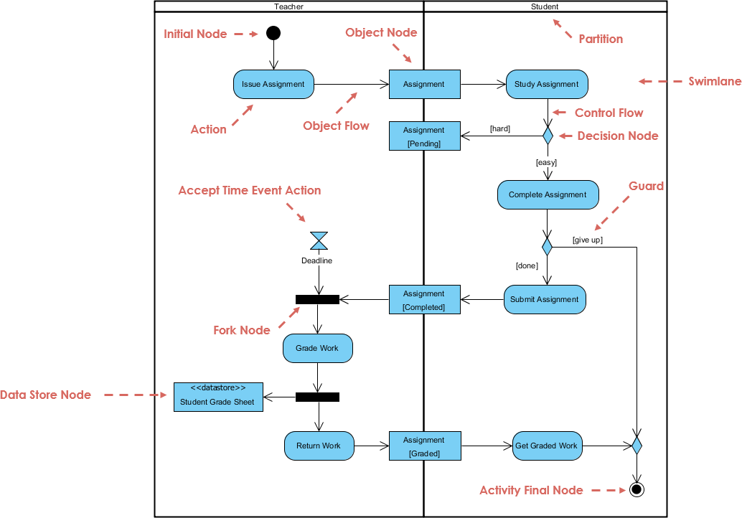

***ERD DIAGRAM – INVENTORY SYSTEM***

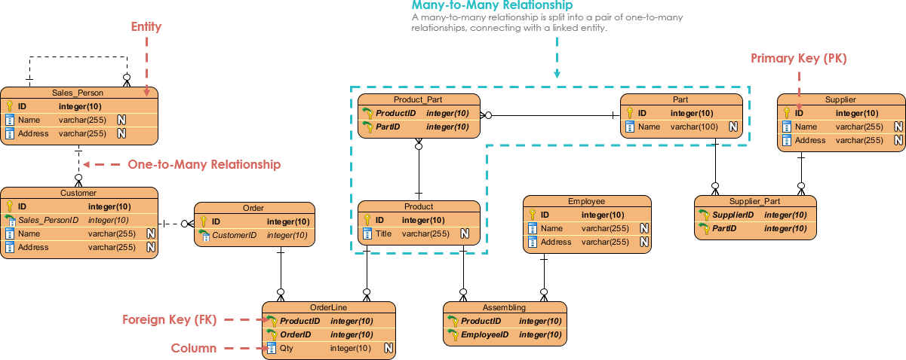

***ERD DIAGRAM – COLLEGE SYSTEM***

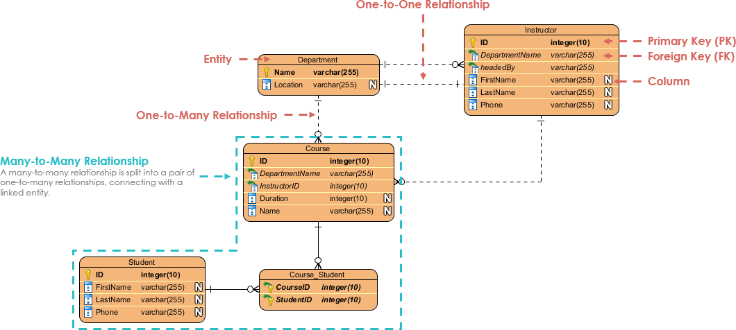

***ERD DIAGRAM – MOVIE DATABASE***

